**Accepting Subsidy for Admissions**

Starting January 2014, all cashiers are able to apply a customer’s Parks and Recreation subsidy to a transaction such as a recreational swim, lane swim, or aquafit admission. Previously, subsidy could only be used for registrations and memberships.   
  
**Subsidy is like our memberships. People may NOT share subsidy. The only time where you may use one person’s subsidy for multiple people is if a parent wants to purchase a family admission. Otherwise, you must repeat this process for each person.**

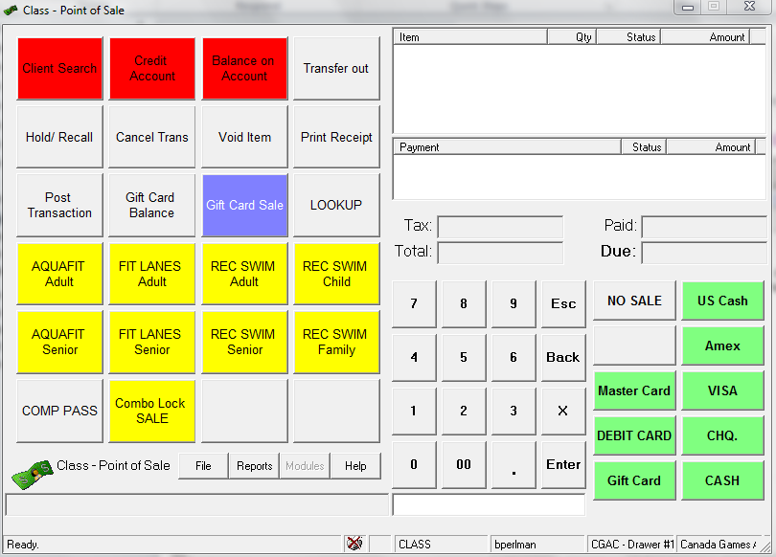If a customer comes to you asking to use their subsidy for admission, please follow these steps.  
  
Open Point of Sale.  Click Client Search   
**Your screen may also have a subsidy button. If so, you may use that instead of client search.**

**STEP 1**

|  |
| --- |
| **NOTE:** The user displayed at the top of the window is the **person you are subsidizing:**  The user displayed at the bottom of the window is the **main contact.**  (Even though it says transaction assigned to, it is actually assigned to the person at the top) |

**STEP 2**

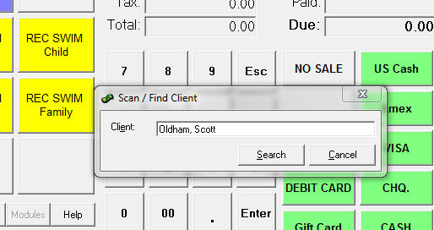A “Scan/Find Client” box will come up.

* 1. Scan the customer’s keytag or type their name or  
     phonenumber.
  2. 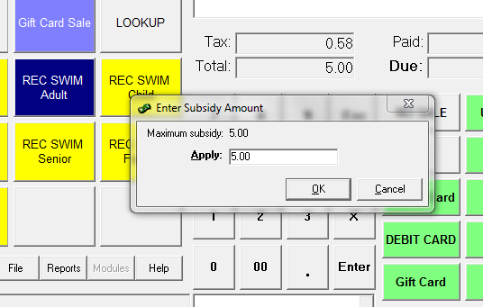If multiple clients are found, select the appropriate   
     client from the list.

**STEP 3**

Click the admission type that you wish to sell,   
i.e. REC SWIM ADULT

* 1. A “Enter Subsidy Amount” box will come up.   
     Customers have a maximum of $300 per year that   
     can be used for subsidy. If they have more available  
     subsidy than the cost of the admission, then the max  
     subsidy will be the admission cost. You may subsidize

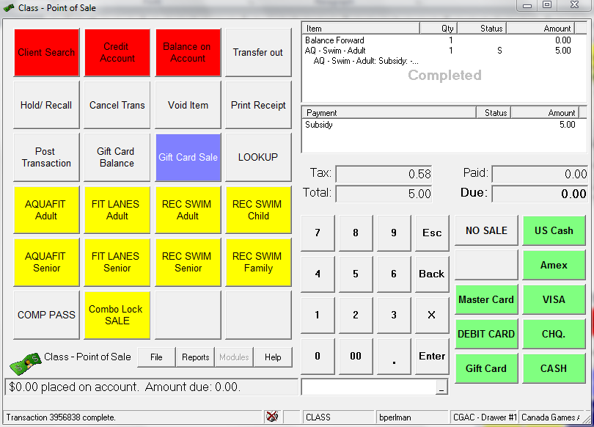all or part of the admission. For example, if the   
customer wishes to pay $2.00 out of pocket for a $5  
admission, you would enter $3.00 in the apply field and click ok.  
If the customer wants to use subsidy for the full cost of the  
admission, enter the maximum amount and click ok.

**STEP 4**

To complete the transaction, click Balance on Account.  
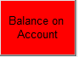  
The transaction window will say “Completed”.